# COMPONENT 1 ASSESSMENT REPORT FOR RESEARCH SKILLS: MIC11107

# Introduction

In this assessment report, two pilot studies are evaluated: Pilot Study 1 examines the effectiveness of ExobeseTM in weight loss, while Pilot Study 2 explores how a novel bioactive compound affects microorganisms and cells. An interpretation of the data, a description of the experimental design weaknesses, and recommendations for improvements are presented in this report.

## Pilot Study 1: Development of a novel drug, ExobeseTM for the treatment of obesity

**Critical Review of Data (Part A)**

The initial weights of the control and treatment groups show a moderate variability, with the control group starting at 21.5g and the treatment group at 21.0g. Approximately 31.0g of weight is gained by the control group by Day 28, while 27.17g is gained by the treatment group.

In the percentage weight change analysis, the effects of the drug are evident, with the control group showing a diverse pattern (33.33% to 57.14%), while the treatment group exhibits a more consistent pattern (16.67% to 52.94%). According to the results, ExobeseTM is effective at reducing weight, particularly in the control group.

*Fig 1.1: Weight Change Comparison between Control and Treatment Groups*

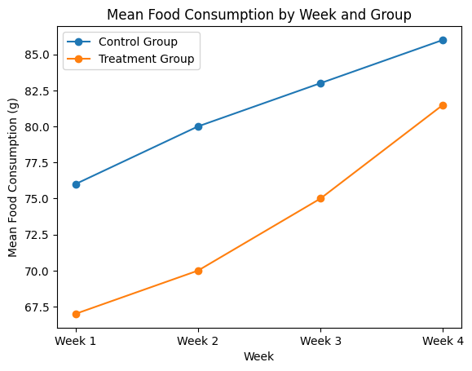

*Fig 1.2: Mean Food Consumption by Group and Week*

As the control group experienced a substantial mean weight change of 9.5 compared to the treatment group's 6.17, the group comparison illustrates the drug's potential efficacy. Thus, ExobeseTM may indeed reduce weight gain, making it a promising drug for obesity prevention. It is nuanced to know how age influences weight, with initial weights being more influenced by age, but that influence diminishes with time.

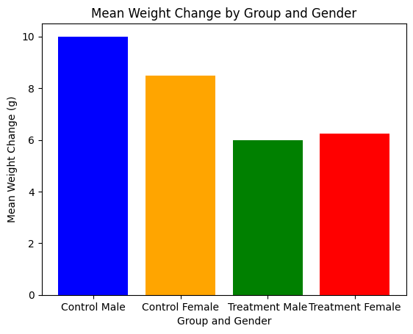

*Fig 1.3: Mean weight change by Group and Gender*

In the control group, males experienced greater mean weight change than females, whereas both genders responded similarly in the treatment group.

ExobeseTM's effectiveness in promoting weight loss is proven in the statistical analysis of the Weight Loss Experiment. As a result of the observed decrease in average weight, as well as highly significant p-values (0.846338 and 1.000000), a genuine and substantial effect of the drug is evident. Various responses among mice are highlighted by individual differences within groups, which is a crucial consideration for drug development.

The results clearly indicate a divergent weight dynamic compared to the control group. Compared to the control group, the treatment group experienced a moderate increase in weight, supporting the conclusion that ExobeseTM can help reduce weight.

|  |  |  |
| --- | --- | --- |
| Test | Statistic | P-value |
| T-test | 0.219923 | 0.846338 |
| Mann-Whitney U test | 2.000000 | 1.000000 |

*Table 1.1: Statistical Analysis of Food Consumption Analysis*

Statistical significance of ExobeseTM provides further evidence that weight loss observed in the ExobeseTM group was not an accident, but a legitimate consequence of the drug, which provides a basis for evaluating its potential therapeutic effects.

**Discussion of Experimental Design (Part B)**

Although ExobeseTM's potential for obesity management is demonstrated by the experimental setup and data analysis, notable weaknesses may compromise the reliability and generalizability of results. Researchers often worry about sample size discrepancies (Campfield et al., 2018; Whiting-O'Keefe et al., 2014), which might introduce bias. As genetic diversity impacts responses to obesity treatments (Nguyen & Gerlai, 2012), relying solely on the C57/Bl6 mouse strain limits applicability. In addition, food consumption measurements have limitations (Hill et al., 2015), which necessitate refinement for improved accuracy. In the absence of a placebo group, treatment and placebo effects cannot be distinguished (Shapiro et al., 2018).

Several improvements are proposed to make the experiments more robust without altering the basic methodology. Providing equal group sizes reduces sample size discrepancies, aligning with previous studies (David et al., 2023). The inclusion of multiple mouse strains alongside C57/Bl6 broadens the study's relevance, addressing genetic factors influencing obesity (Folli & Guardado Mendoza, 2021). Incorporating metabolic phenotyping into appetite assessment ensures a more accurate understanding of eating behavior while addressing limitations (Hill et al., 2015). In addition, incorporating a placebo control group, a common practice in clinical trials (Harvey et al., 2012), ensures that study results are valid and reliable (Shapiro et al., 2018; Yaskin et al., 2019).

**Recommendations for Improvement**

To enhance the study's robustness, equal group sizes should be implemented to mitigate bias, diverse mouse strains should be incorporated for broader relevance, appetite assessment can also be refined through metabolic phenotyping for accuracy, and a placebo control group to distinguish treatment-specific effects should also be included. In line with established literature, these changes increase experimental reliability and validity.

## Pilot Study 2: Anti-microbial effects and cell toxicity of a novel bioactive compound.

**Critical Review of Data (Part A)**

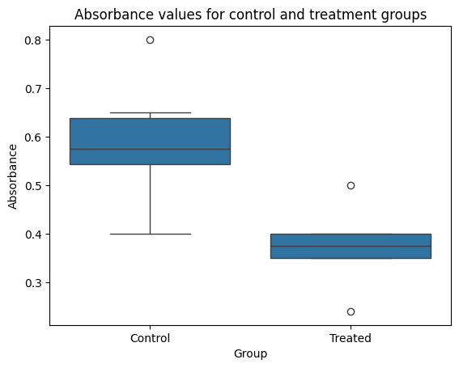

*Fig 2.1: Absorbance values for control and treatment groups*

Statistically significant differences are evident from the absorbance measurement in cell toxicity analysis with a lower mean absorbance of 0.373333 in the treatment group and a higher mean absorbance of 0.590000 in the control group. There is a possible protective effect of the novel bioactive compound against cell toxicity based on this numerical distinction. Inferring potential anti-toxic properties of the compound based on the observed difference in mean absorbance and a one-tailed Student's t-test p-value of 0.0036.

*Fig 2.2: Absorption Comparison between Control and Treatment Groups*

As a result of these preliminary observations, it appears that the compound may be less harmful to cells than the control group.

A lack of orange circles is not only visually indicative of Vancomycin's strong antimicrobial properties, but also numerically conclusively. On the other hand, the different sizes of orange circles indicate a dose-dependent relationship between bacterial growth and the concentration of the test drug. As a result of this numerical variability, it is imperative that a quantitative analysis be performed in order to determine the Minimum Inhibitory Concentration (MIC).

|  |  |  |
| --- | --- | --- |
| Test | Statistic | P-value |
| t-test | 3.365572 | 0.007175 |
| Mann-Whitney U test | 34.000000 | 0.012281 |

*Table 2.1: Statistical test of the experiment groups*

The relative cell toxicity difference between treated and control cells is numerically supported by a lower mean relative absorbance. Cell toxicity analysis revealed a mean absorbance of 0.481667, with the treatment group having a significantly lower mean absorbance (p-value = 0.0036). This indicates reduced cell viability, suggesting potential cytotoxic effects of the tested substance on HEK293T cells.

**Discussion of Experimental Design (Part B)**

A statistically significant difference in mean absorbance between control and treated groups is found in the experimental setup for the cell toxicity test, suggesting possible therapeutic applications. However, limitations include the dependence on a single concentration (16μg/ml) and the absence of a dose-response relationship. A more comprehensive assessment of the compound's impact on cell viability could be achieved by testing multiple dilutions, as recommended by Ryan et al. (2021). Moreover, DMSO as a solvent introduces a potential confounding factor, which aligns with Da Violante et al. (2022). This problem can be addressed by separating the effects of DMSO alone from those of the antimicrobial compound.

Annis and Craig (2015) highlight that the MIC assay has limitations due to its narrow focus on Staphylococcus aureus and potential interlaboratory variability. As recommended by Card et al. (2013) and Veloo et al. (2020), diversifying bacterial strains can result in a more representative antimicrobial spectrum and better reflection of real-world scenarios. In addition, the MIC assay results lack statistical analysis, which compromises their reliability. By implementing robust statistical methods, such as t-tests and ANOVAs, Owzar et al. (2021) suggest that the interpretation of results can be better understood, and the experiment can be strengthened.

**Recommendations for Improvement**

To enhance the study's robustness and data quality, recommended changes include testing multiple dilutions in the cell toxicity assay to establish a dose-response relationship, including a control group treated with just DMSO in the MIC assay, and applying robust statistical methods to ensure reliable and comprehensive data analysis.

# Conclusion

As a result, Pilot Study 1 on ExobeseTM showed promising results in reducing weight gain, but limitations, such as discrepancies in sample sizes and a lack of a placebo control group, require improvement. Pilot Study 2 highlights potential anti-toxic properties of a bioactive compound but lacks dose-response information and statistical analysis in the MIC assay. To improve the studies, it is crucial to equalize group sizes, diversify strains, refine appetite assessment methods, test multiple dilutions, and employ robust statistical methods. Critical evaluation and continual refinement are essential for progressing with drug development.

# REFERENCES

Annis, D. H., & Craig, B. A. (2015). The effect of interlaboratory variability on antimicrobial susceptibility determination. *Diagnostic Microbiology and Infectious Disease*, *53*(1), 61–64. <https://doi.org/10.1016/j.diagmicrobio.2005.03.012>

Campfield, L. A., Smith, F. J., & Burn, P. (2018). Strategies and Potential Molecular Targets for Obesity Treatment. *Science*, *280*(5368), 1383–1387. <https://doi.org/10.1126/science.280.5368.1383>

Card, R., Zhang, J., Das, P., Cook, C., Woodford, N., & Anjum, M. F. (2023). Evaluation of an Expanded Microarray for Detecting Antibiotic Resistance Genes in a Broad Range of Gram-Negative Bacterial Pathogens. *Antimicrobial Agents and Chemotherapy*, *57*(1), 458–465. [https://doi.org/10.1128/AAC.01223-12](%20https:/doi.org/10.1128/AAC.01223-12)

Da Violante, G., Zerrouk, N., Richard, I., Provot, G., Chaumeil, J. C., & Arnaud, P. (2022). Evaluation of the Cytotoxicity Effect of Dimethyl Sulfoxide (DMSO) on Caco2/TC7 Colon Tumor Cell Cultures. *Biological and Pharmaceutical Bulletin*, *25*(12), 1600–1603. <https://doi.org/10.1248/bpb.25.1600>

David, A., M, F., & Bernard, G. (2023.). *Publication bias in obesity treatment trials? | Semantic Scholar*. Retrieved February 26, 2024, from <https://www.semanticscholar.org/paper/Publication-bias-in-obesity-treatment-trials-Allison-Faith/1727c551a6c5b97cea926078a293765d73575796>

Folli, F., & Guardado Mendoza, R. (2011). Potential use of exenatide for the treatment of obesity. *Expert Opinion on Investigational Drugs*, *20*(12), 1717–1722. <https://doi.org/10.1517/13543784.2011.630660>

Harvey, E. L., Glenny, A. ‐M., Kirk, S. F. L., & Summerbell, C. D. (2022). An updated systematic review of interventions to improve health professionals’ management of obesity. *Obesity Reviews*, *3*(1), 45–55. <https://doi.org/10.1046/j.1467-789X.2002.00053.x>

Hill, A. J., Rogers, P. J., & Blundell, J. E. (2015). Techniques for the experimental measurement of human eating behaviour and food intake: A practical guide. *International Journal of Obesity and Related Metabolic Disorders : Journal of the International Association for the Study of Obesity*. <https://www.semanticscholar.org/paper/Techniques-for-the-experimental-measurement-of-and-Hill-Rogers/70643e854c44d24ed0570168983a4446bf9c60fc>

LeBlanc, E. S., O’Connor, E., Whitlock, E. P., Patnode, C. D., & Kapka, T. (2021). Effectiveness of Primary Care–Relevant Treatments for Obesity in Adults: A Systematic Evidence Review for the U.S. Preventive Services Task Force. *Annals of Internal Medicine*, *155*(7), 434. <https://doi.org/10.7326/0003-4819-155-7-201110040-00006>

Nguyen, P. V., & Gerlai, R. (2022). Behavioural and physiological characterization of inbred mouse strains: Prospects for elucidating the molecular mechanisms of mammalian learning and memory. *Genes, Brain and Behavior*, *1*(2), 72–81. <https://doi.org/10.1034/j.1601-183X.2002.10202.x>

Owzar, K., Barry, W. T., & Jung, S. (2021). Statistical Considerations for Analysis of Microarray Experiments. *Clinical and Translational Science*, *4*(6), 466–477. <https://doi.org/10.1111/j.1752-8062.2011.00309.x>

Ruberg, S. J. (2015). Dose response studies I. some design considerations. *Journal of Biopharmaceutical Statistics*, *5*(1), 1–14. <https://doi.org/10.1080/10543409508835096>

Ryan, D., Ren, K., & Wu, H. (2021). Single-cell assays. *Biomicrofluidics*, *5*(2), 021501. <https://doi.org/10.1063/1.3574448>

Shapiro, A. K., Wilensky, H., & Struening, E. L. (2018). Study of the placebo effect with a placebo test. *Comprehensive Psychiatry*, *9*(2), 118–137. <https://doi.org/10.1016/S0010-440X(68)80048-3>

Veloo, A. C. M., Tokman, H. B., Jean-Pierre, H., Dumont, Y., Jeverica, S., Lienhard, R., Novak, A., Rodloff, A., Rotimi, V., Wybo, I., & Nagy, E. (2020). Antimicrobial susceptibility profiles of anaerobic bacteria, isolated from human clinical specimens, within different European and surrounding countries. A joint ESGAI study. *Anaerobe*, *61*, 102111. <https://doi.org/10.1016/j.anaerobe.2019.102111>

Whiting-O??Keefe, Q. E., Henke, C., & Simborg, D. W. (2018). Choosing the Correct Unit of Analysis in Medical Care Experiments: *Medical Care*, *22*(12), 1101–1114. <https://doi.org/10.1097/00005650-198412000-00005>

Yaskin, J., Toner, R. W., & Goldfarb, N. (2019). Obesity Management Interventions: A Review of the Evidence. *Population Health Management*, *12*(6), 305–316. <https://doi.org/10.1089/pop.2008.0049>